42.52: a) From Problem (42.51):
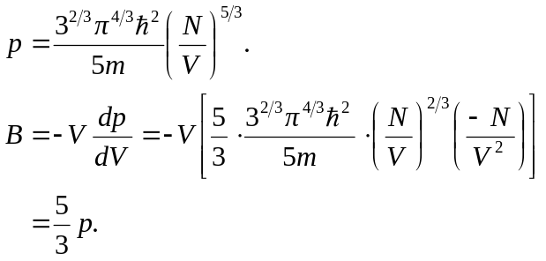
b) 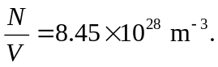
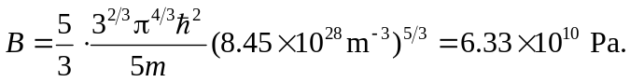
c) 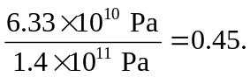The copper ions themselves make up the remaining fraction.

